TYPE A STEP-DOWN MOSFET CHOPPER

AIM: To study the operation of a type A step-down MOSFET chopper.

APPARATUS: 1) Circuit board.
2) DMM.
3) Ammeter.
4) Dual trace CRO with probes.

NOMENCLATURE:

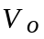(i) : average (DC) output (load) voltage
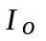
(ii) : average (DC) output (load) current
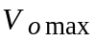
(iii) : maximum (peak) output voltage
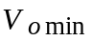
(IV) : minimum (peak) output voltage
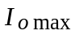
(v) : maximum (peak) output current
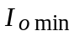
(vi) : minimum (peak) output current

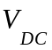(Vii) : DC supply voltage

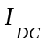(Viii) : average (DC) supply current

(ix) t_{ON} : duration for which the switch is ON

(x) t_{OFF} : duration for which the switch is OFF

(xi) t_{FWD} : duration for which the output current freewheels through the FWD

(xii) f = 1/T : chopper frequency

(xiii) K : chopper duty cycle
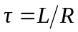
(Xiv) : load time constant

(xv) L : load inductance

(xvi) R : total resistance of current sensing resistor, ammeter & load (including the winding
resistance of the load inductance, for inductive loads)
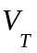
(Xvii) : ON-state voltage drop of the MOSFET
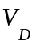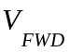
(xviii) ( ): ON-state voltage drop of the freewheeling diode
THEORY:

A type A step-down chopper is a fixed DC-to-variable DC convertor whose average output voltage can be continuously varied from zero to the fixed DC supply voltage using pulse width modulation.

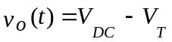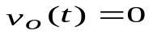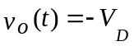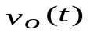The schematic diagram of an ideal step-down chopper circuit is shown in Fig. 1 & consists of a controlled switch S1 and freewheeling diode (FWD) D1. During the ON period of the switch, the output voltage, , is given by ideally, ( actually). Similarly, during the OFF period for an inductive load, the output voltage is given by ideally,
( actually, as long as the FWD is conducting). During the OFF period, for a resistive load,
for both ideal and actual cases.
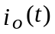Therefore the output voltage waveform, shown in Fig. 5, is a rectangular pulse train of amplitude
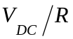at a frequency f having a duty cycle K and is practically independent of the type of load. However the output current depends on the load and is also shown in Fig. 5 for resistive, discontinuous & continuous inductive loads. For a resistive load, voltage and current are in phase, and therefore the current waveform is a rectangular pulse train at frequency f and with an amplitude of . Further the FWD D1 does not conduct at all and therefore the current is carried only by switch S1. Hence the supply current waveform is identical to the load current waveform.

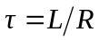For an inductive load, the output current cannot change instantaneously and therefore builds-up & decays at a rate governed by the load time constant . In the case of a discontinuous inductive load, the current builds-up from zero to during the ON period and the supply current equals the load current. When switch S1 turns-off at the beginning of the OFF period, the stored magnetic energy in the inductive load causes the load current to freewheel through D1 by reversing the polarity of the output voltage and forward biasing D1. The current decays exponentially to zero before the start of the next ON period, and during this period the supply current is zero as switch S1 is OFF. Thus the freewheeling duration t_{FWD} is less than the OFF period .

In contrast, for a continuous inductive load in the steady state, the load current never falls to zero but builds up from to during t_{ON} and decays from to during t_{OFF}. Here the freewheeling duration t_{FWD} is equal to the OFF period.

CIRCUIT DESCRIPTION:

1. Power circuit: The power circuit diagram of the step-down chopper is shown in Fig.3 and consists of power MOSFET T11 (IRF840) acting as switch S1 & power MOSFET D27 (IRF840), with gate shorted-to-source, acting as free wheeling diode D1. The DC supply to the chopper is obtained by stepping down the mains supply using 230V/26V step-down transformer TR3, and then full-wave rectifying the output voltage using diodes D41 to D43 in a bridge configuration with capacitor C41 as filter capacitor.

2. Control circuit: The control circuit is shown in Fig. 2, while the control circuit waveforms are shown in Fig. 4.

The control circuit delivers a rectangular gate pulse train of duration t_{ON} from t = 0 to t = t_{ON} in each cycle to the power MOSFET switch S1, with t_{ON} being settable, ideally, from 0 to T corresponding to a duty cycle variation of 0 to 1.
2.1. Triangular waveform generator: A triangular wave oscillator is formed by VCO U1 (LM566) with resistors R1, R2, R3, capacitor C1 and frequency setting potentiometer R3. The frequency f of the triangular voltage waveform (pin 4) , can be calculated using following formulae:
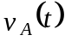
(1)

This frequency can be adjusted by potentiometer R3.
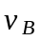2.2. Pulse train generator: The triangular voltage waveform is compared with a reference DC voltage in comparator U2 (LF356), which produces a rectangular waveform of frequency f and duty cycle K. The duty cycle can be adjusted by varying the reference voltage by means of potentiometer R6.

2.3. Driver & isolation circuits: In power electronics isolation between the control and power circuits is essential and is usually provided either by pulse transformers or opt couplers. In the present case this isolation is achieved using opt couplers.

Since opt couplers require driving currents of the order of 10mA, the output of the pulse train generator is buffered by a complementary symmetry transistor driver circuit consisting of transistors T1 (BC547), T2 (BC557) and base current control resistor R9, and is then used to drive the opto-diode of opt coupler U3 (MCT2E) via resistors R11 & R12.

Owing to the finite bandwidth of the opt coupler, the output pulses delivered by it to the power circuit have relatively large rise and fall times which are unacceptable. Hence Schmitt comparator U6 (4093), along with pull-up resistor R21, is used to ‘sharpen’ these pulses which are then given to hex non-inverting buffer U7 (4050) with paralleled inputs and outputs. The turn-on and turn-off times of the MOSFET can be controlled by the current limiting resistance R22 // R23 in series between the buffer output and MOSFET gate terminal, which essentially controls the rate of charge and discharge of C_{GS}, the MOSFET gate-source capacitance.

Switch SW2, along with transistor switch T3 (BC547) and resistors R13, R14 & R15, is used to enable or disable the control circuit.

2.4. Test points:

2.4.1. Control circuit:
TP1: triangular voltage A
TP2: reference DC voltage B
TP3: pulse train output C

2.4.2. Driver circuit:

TP4: gate pulses for MOSFET switch S1 D
FORMULAE:

1. Output voltage (ideal):
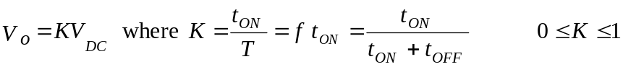
(1)
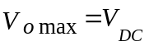
(2)
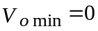
(3)

2. Output voltage (actual):

2.1 R load:

(4)

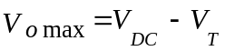 (5)

(6)

2.2 Discontinuous inductive load:
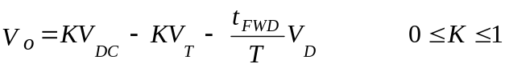
(7)

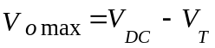 (8)

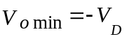 (9)

2.3 Continuous inductive load:
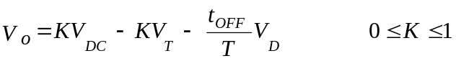
(10)

(11)

(12)

3. Average (DC) output current (for all cases):
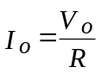
(13)

4. Maximum, minimum and p-p ripple current for continuous inductive load:
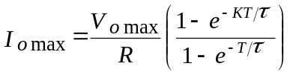
(14)

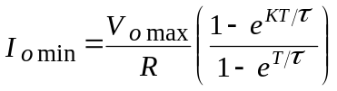
(15)

(16)

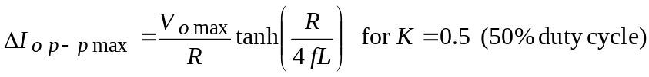
(17)

PROCEDURE:

1. Keeping power circuit switch SW3 OFF, switch ON control circuit switch SW1. Connect channel 1 of the CRO to observe the triangular output voltage (live of probe to TP1 & common to control ground X5) and channel 2 to observe the pulse train output voltage (live of probe to TP3 & common to X5). Vary frequency control potentiometer R3 and duty cycle control potentiometer R6 and observe the variation of and draw to scale both these waveforms.

Measure minimum and maximum frequencies f_{min} & f_{max}, respectively, and minimum and maximum duty cycles K_{min} & K_{max}, respectively.

2. Disconnect both live & common of probe connected to channel 1 and then connect it to observe the gate pulses given to the MOSFET switch (live of probe to TP4 & common to isolated (power) ground X8). Draw to scale and compare the gate pulse waveform with the pulse train output waveform in the control circuit.

3. R load:

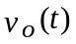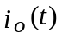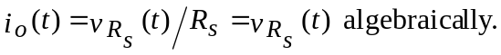3.1. Switch OFF SW1 and disconnect both channels of the CRO. Put SW2 in ‘R’ position and switch ON SW3and then SW1. Connect channel 1 of the CRO to observe the output voltage (live of probe to X14 & common to X18). Also connect channel 2 to observe the output current by sensing the voltage across 1 Ω current-sensing resistor R_{s} (live of probe to X17 & common to X18). Note that
Observe and draw to scale both these waveforms.

3.2. Adjust the output frequency to f₁ and duty cycle to K₁ and measure the following parameters:

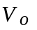(i) DC output voltage
(ii) DC output current

(iii) Maximum (peak) output voltage

(iv) Maximum (peak) output current

(v) Period T

(vi) ON period t_{ON}

(vii) DC supply voltage

(viii) DC supply current

Repeat these measurements for output frequency f₂ and duty cycle to K₂.

4. Discontinuous inductive load:

4.1. Switch OFF SW1 and then SW3. Put switch SW2 in L position and switch ON SW3 & then SW1. Connect both channels of the CRO to measure output voltage & current as given in 3.1 above.

4.2. Adjust the output frequency to f₃ and duty cycle to K₃ such that the output current is discontinuous (Fig. 5). Observe and draw to scale both the output voltage & current waveforms. Measure the following parameters:
(i) DC output voltage
(ii) DC output current

(iii) Maximum (peak) output voltage

(iv) Maximum (peak) output current

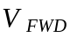(v) freewheeling output voltage

(vi) Period T

(vii) ON period t_{ON}

(viii) freewheeling duration t_{FWD}

(ix) DC supply voltage

(x) DC supply current

Repeat these measurements for another output frequency f₄ and another duty cycle to K₄ (discontinuous conduction).

5. Continuous inductive load:

5.1. Adjust the output frequency to f₅ and duty cycle to K₅ such that the output current is continuous (Fig. 5). Observe and draw to scale both the output voltage & current waveforms. Measure the following parameters:

(i) DC output voltage
(ii) DC output current

(iii) maximum (peak) output voltage

(iv) maximum (peak) output current
(v) minimum output current

(vi) freewheeling output voltage

(vii) period T

(viii) ON period t_{ON}

(ix) freewheeling duration t_{FWD}

(x) DC supply voltage

(xi) DC supply current

Repeat these measurements for another output frequency f₆ and 50% duty cycle i.e. K₆ = 0.5 (continuous conduction).

OBSERVATIONS:

1. Minimum output frequency f_{min} = Hz

2. Maximum output frequency f_{max} = Hz

3. Minimum output duty cycle K_{min} =

4. Maximum output duty cycle K_{max} =

5. R load:

R = Ω

Sr. No. | Parameter | f₁ = Hz, K₁ = | f₂ = Hz, K₂ =
1. | V
2. | A
3. | V
4. | A
5. | T ms
6. | t_{ON} ms
7. | V
8. | A

6. Discontinuous inductive load:

 = Ω

L = mH

Sr. No. | Parameter | f₃ = Hz, K₃ = | f₄ = Hz, K₄ =
1. | V
2. | A
3. | V
4. | A
5. | V
6. | T ms
7. | t_{ON} ms
8. | t_{FWD} ms
9. | V
10. | A

7. Continuous inductive load:

= Ω

L = mH

Sr. No. | Parameter | f₅ = Hz, K₅ = | f₆ = Hz, K₆ = 0.5
1. | V
2. | A
3. | V
4. | A
5. | A
6. | V
7. | T ms
8. | t_{ON} ms
9. | t_{FWD} ms
10. | V
11. | A

CALCULATIONS & VERIFICATIONS:

1. Output voltage (ideal):

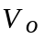For all loads calculate as per equation (1) above.

2. Output voltage (actual):

For the R load make verifications as per equations (4) to (6) above, for the discontinuous inductive load as per equations (7) to (9) above and for the continuous inductive load as per equations (10) to (12) above.

3. Output current (actual):

For all loads make verifications as per equation (13) above.

4. Maximum, minimum and p-p ripple current

For the continuous inductive load make verifications as per equations (14) to (17) above.

RESULT TABLES:

1. Output voltage (ideal):

Parameter | R load |  | Discont. inductive load |  | Cont. inductive load
Parameter | f₁ , K₁ | f₂ , K₂ | f₃ , K₃ | f₄ , K₄ | f₅ , K₅ | f₆ , K₆
V

2. Output voltage (actual):

Parameter | R load |  |  |  | Discont. inductive load |  |  |  |  | Cont. inductive load
Parameter | Measured |  | Calculated |  |  | Measured |  | Calculated |  |  | Measured |  | Calculated
Parameter | f₁ ,K₁ | f₂ ,K₂ | f₁ ,K₁ | f₂ ,K₂ |  | f₃ ,K₃ | f₄ ,K₄ | f₃ ,K₃ | f₄ ,K₄ |  | f₅ ,K₅ | f₆ ,K₆ | f₅ ,K₅ | f₆ ,K₆
V
V
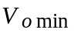 V

3. Output current (actual):

Parameter | R load |  |  |  | Discont. inductive load |  |  |  | Cont. inductive load
Parameter | Measured |  | Calculated |  | Measured |  | Calculated |  | Measured |  | Calculated
Parameter | f₁ ,K₁ | f₂ ,K₂ | f₁ ,K₁ | f₂ ,K₂ | f₃ ,K₃ | f₄ ,K₄ | f₃ ,K₃ | f₄ ,K₄ | f₅ ,K₅ | f₆ ,K₆ | f₅ ,K₅ | f₆ ,K₆
A

4. Maximum, minimum and p-p ripple current:

Parameter | Cont. inductive load
Parameter | Measured |  | Calculated
Parameter | f₅ ,K₅ | f₆ ,K₆ | f₅ ,K₅ | f₆ ,K₆
A
A
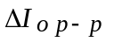 A
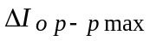 A

CONCLUSIONS:

